1. 
2. 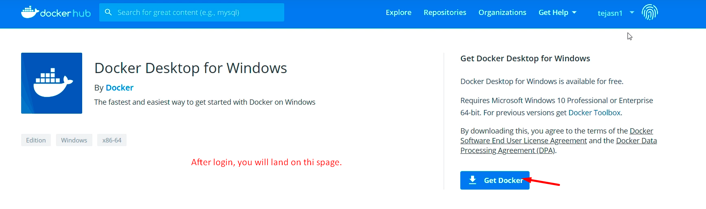
3. 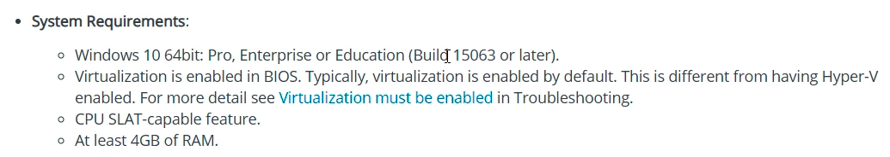
4. 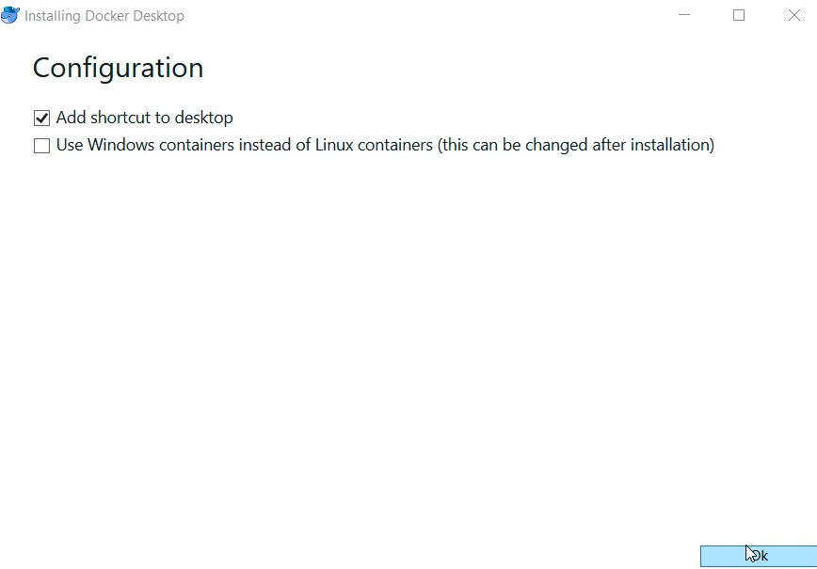
5. Let’s make sure that Docker is running.
   1. Two ways
      1. 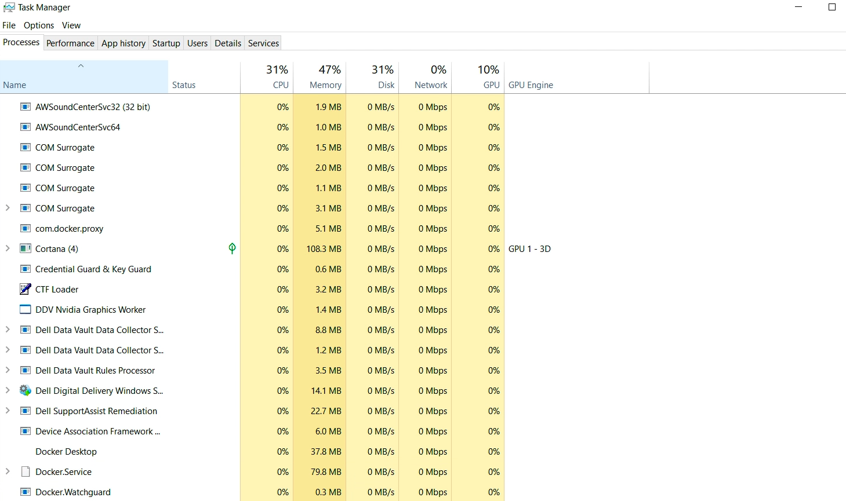
      2. 